BANK LOAN REPORT

SUMMARY DASHBOARD

Total Loan Applications:
SELECT COUNT(id) AS Total_Loan_Applications FROM bank_loan_data;
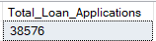

Month to Date Loan Applications :
SELECT COUNT(id) AS MTD_Total_Loan_Applications FROM bank_loan_data
WHERE MONTH(issue_date) = 12 AND YEAR(issue_date) = 2021;
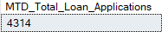

Previous Month to Date Applications:
SELECT COUNT(id) AS PMTD_Total_Loan_Applications FROM bank_loan_data
WHERE MONTH(issue_date) = 11 AND YEAR(issue_date) = 2021;
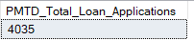

Total Funded Amount:
SELECT SUM(loan_amount) AS Total_Funded_Amount FROM bank_loan_data;
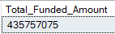

Month to Date Total Funded Amount:
SELECT SUM(loan_amount) AS MTD_Total_Funded_Amount FROM bank_loan_data
WHERE MONTH(issue_date) = 12 AND YEAR(issue_date) = 2021;
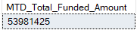

Previous Month to Date Total Funded Amount:
SELECT SUM(loan_amount) AS PMTD_Total_Funded_Amount FROM bank_loan_data
WHERE MONTH(issue_date) = 11 AND YEAR(issue_date) = 2021;
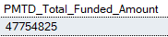

Total Amount Received:
SELECT SUM(total_payment) AS Total_Amount_Received FROM bank_loan_data;
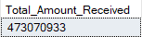

Month to Date Total Amount Received:
SELECT SUM(total_payment) AS MTD_Total_Amount_Received FROM bank_loan_data
WHERE MONTH(issue_date) = 12 AND YEAR(issue_date) = 2021;
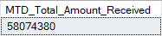

Previous Month to Date Total Amount Received:
SELECT SUM(total_payment) AS PMTD_Total_Amount_Received FROM bank_loan_data
WHERE MONTH(issue_date) = 11 AND YEAR(issue_date) = 2021;
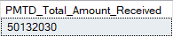

Average Interest Rate:
SELECT ROUND(AVG(int_rate)*100,2) AS Avg_Interest_Rate FROM bank_loan_data;
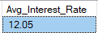

Month to Date Average Interest Rate:
SELECT ROUND(AVG(int_rate)*100,2) AS MTD_Avg_Interest_Rate FROM bank_loan_data
WHERE MONTH(issue_date) = 12 AND YEAR(issue_date) = 2021;
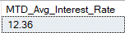

Previous Month to Date Average Interest Rate:
SELECT ROUND(AVG(int_rate)*100,2) AS PMTD_Avg_Interest_Rate FROM bank_loan_data
WHERE MONTH(issue_date) = 11 AND YEAR(issue_date) = 2021;
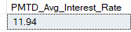

Average DTI:
SELECT ROUND(AVG(dti)*100,2) AS Avg_DTI FROM bank_loan_data;
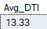

Month to Date Average DTI:
SELECT ROUND(AVG(dti)*100,2) AS MTD_Avg_DTI FROM bank_loan_data
WHERE MONTH(issue_date) = 12 AND YEAR(issue_date) = 2021;
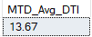

Previous Month to Date Average DTI:
SELECT ROUND(AVG(dti)*100,2) AS PMTD_Avg_DTI FROM bank_loan_data
WHERE MONTH(issue_date) = 11 AND YEAR(issue_date) = 2021;
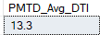

GOOD LOANS
Good Loan Percentage:
SELECT
(COUNT(CASE WHEN loan_status = 'Fully Paid' OR loan_status='Current' THEN id END)*100.0)
/
COUNT(id) as Per_Good_Loan
FROM bank_loan_data;
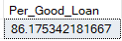

Good Loan Applications:
SELECT COUNT(id) AS Good_Loan_Applications FROM bank_loan_data
WHERE loan_status = 'Fully Paid' OR loan_status='Current';
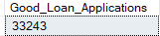

Good Loan Funded Amount:
SELECT SUM(loan_amount) AS Good_Loan_Funded_Amount FROM bank_loan_data
WHERE loan_status IN ('Fully Paid','Current');
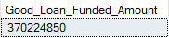

Good Loan Total Amount Received:
SELECT SUM(total_payment) AS Good_Loan_Amount_Received FROM bank_loan_data
WHERE loan_status IN ('Fully Paid','Current');
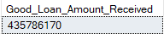

BAD LOANS
Bad Loan Percentage:
SELECT
(COUNT(CASE WHEN loan_status = 'Charged Off' THEN id END)*100.0)
/
COUNT(id) as Per_Bad_Loan
FROM bank_loan_data;
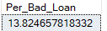

Bad Loan Applications:
SELECT COUNT(id) AS Bad_Loan_Applications FROM bank_loan_data
WHERE loan_status = 'Charged Off';
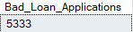

Bad Loan Funded Amount:
SELECT SUM(loan_amount) AS Bad_Loan_Funded_Amount FROM bank_loan_data
WHERE loan_status = 'Charged Off';
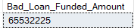

Bad Loan Total Amount Received:
SELECT SUM(total_payment) AS Bad_Loan_Amount_Received FROM bank_loan_data
WHERE loan_status = 'Charged Off';
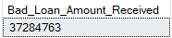

Grid Views:
SELECT loan_status,COUNT(id) AS LoanCount, SUM(total_payment) AS Total_Amount_Received,
SUM(loan_amount) AS Total_Funded_Amount, AVG(int_rate*100) AS Interest_Rate, AVG(dti*100) AS DTI
FROM bank_loan_data
GROUP BY loan_status;
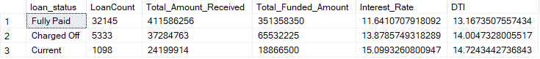

SELECT loan_status,
SUM(total_payment) AS MTD_Total_Amount_Received,
SUM(loan_amount) AS MTD_Total_Loan_Funded
FROM bank_loan_data
WHERE MONTH(issue_date)=12
GROUP BY loan_status;
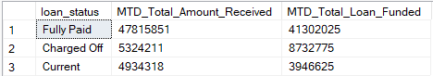

OVERVIEW DASHBOARD

Monthly Trends:
SELECT Month(issue_date) AS Month_Number,
DATENAME(MONTH,issue_date)AS Month_Name,
COUNT(id) AS Total_Loan_Applications,
SUM(loan_amount) as Total_Funded_Amount,
SUM(total_payment)as Total_Received_Amount
FROM bank_loan_data
GROUP BY DATENAME(MONTH,issue_date),Month(issue_date)
ORDER BY Month(issue_date);

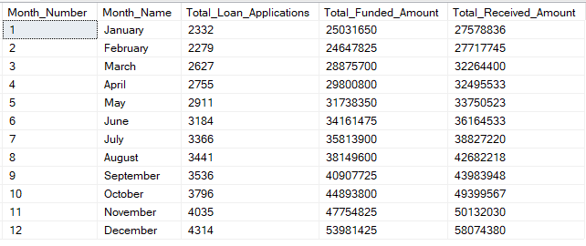

Regional Trends:
SELECT address_state,
COUNT(id) AS Total_Loan_Applications,
SUM(loan_amount) as Total_Funded_Amount,
SUM(total_payment)as Total_Received_Amount
FROM bank_loan_data
GROUP BY address_state
ORDER BY SUM(loan_amount)DESC;
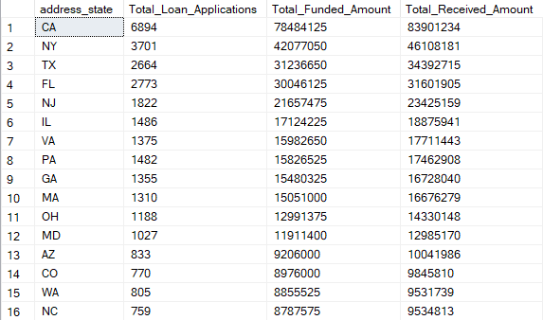

Loan Term Trends:
SELECT term,
COUNT(id) AS Total_Loan_Applications,
SUM(loan_amount) as Total_Funded_Amount,
SUM(total_payment)as Total_Received_Amount
FROM bank_loan_data
GROUP BY term
ORDER BY term;
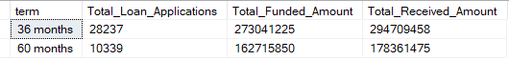

EMPLOYEE LENGTH TRENDS:
SELECT emp_length,
COUNT(id) AS Total_Loan_Applications,
SUM(loan_amount) as Total_Funded_Amount,
SUM(total_payment)as Total_Received_Amount
FROM bank_loan_data
GROUP BY emp_length
ORDER BY COUNT(id) DESC;
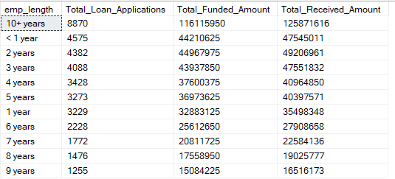

PURPOSE TRENDS:
SELECT purpose,
COUNT(id) AS Total_Loan_Applications,
SUM(loan_amount) as Total_Funded_Amount,
SUM(total_payment)as Total_Received_Amount
FROM bank_loan_data
GROUP BY purpose
ORDER BY COUNT(id) DESC;
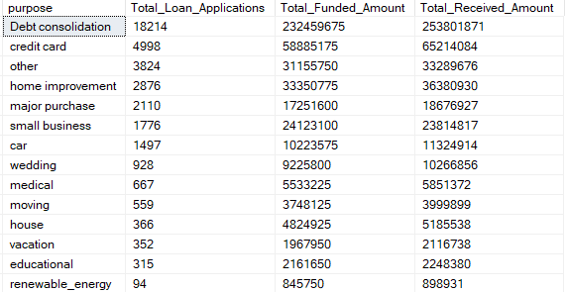

House Ownership Trends:
SELECT home_ownership,
COUNT(id) AS Total_Loan_Applications,
SUM(loan_amount) as Total_Funded_Amount,
SUM(total_payment)as Total_Received_Amount
FROM bank_loan_data
GROUP BY home_ownership
ORDER BY COUNT(id) DESC;




